


FINAL PORTFOLIO (REGRESSION)

Name: Biplov Maharjan
Student ID: 2462258
Tutor: Raju Karki
Module: Concepts and Technologies of AI

Contents
Avocado Price Prediction Analysis 2
1. Introduction 2
1.1 Problem Statement 2
1.2 Dataset 2
1.3 Objective 2
2. Methodology 3
2.1 Data Preprocessing 3
2.2 Exploratory Data Analysis (EDA) 3
2.3 Model Building 6
Task 1 - Neural Network Regressor 6
Task 2 - Classical Machine Learning Models 7
2.4 Model Evaluation 7
2.5 Hyperparameter Optimization 8
2.6 Feature Selection 8
3. Results and Conclusion 8
3.1 Neural Network Performance 8
3.2 Classical Machine Learning Models 9
3.3 Key Findings 10
3.4 Final Model 10
3.5 Challenges 11
3.6 Future Work 11
4. Discussion 12
4.1 Model Performance 12
4.2 Impact of Hyperparameter Tuning and Feature Selection 12
4.3 Interpretation of Results 12
4.4 Limitations 13
4.5 Suggestions for Future Research 13
5. References 14

1. Introduction

1.1 Problem Statement
The main objective of this project is to predict the average price of avocados using past market data. Price prediction plays an important role in the agricultural market, as it helps farmers plan their harvest, distributors manage supply, retailers decide pricing strategies, and consumers make informed purchasing decisions. In this project, regression techniques are used to analyze historical data and understand how factors such as sales volume, avocado type, packaging size, region, and time affect avocado prices, allowing us to estimate future price trends.

1.2 Dataset
For this project, we're using the Avocado Prices dataset. It's built from weekly retail scanner data, looking at what's happened with prices over timestep markets are quite something these days. It keeps track of how many avocados are sold and what they cost at stores all over the country. So, we're looking at a dataset with 18,249 entries. It covers a few years, from 2015 right up to 2018, and it pulls info from different parts of the U.S.

So, the dataset has 14 features. You'll find things like the week's end date, the going avocado price (that's what we're trying to predict), and the overall sales. It also breaks down sales by avocado size—small, large, and extra-large, using their PLU codes—and by different bag sizes. There's info on whether they're conventional or organic avocados, the particular year, and the region they're from. The big thing we're trying to figure out is the Average Price, which is what one avocado usually goes for in stores.

This data ties right into UN Sustainable Development Goal 2: Zero Hunger, especially target 2. Number three is all about helping small farmers grow more and make a better living. Looking at how prices change helps make smarter choices about what to charge, which in turn makes the whole farming and food supply process work a lot smoother. This also fits right in with SDG 12, which is all about responsible consumption and production. If we can do a better job predicting prices, it means less waste in the supply chain, especially with food.

1.3 Objective
We want to make some regression models to predict avocado prices using market information. For this project, we plan to train a neural network regression model. We will also make two old-school machine learning regression models, like Ridge and K-Nearest Neighbors. It's important to make these models work well, so we'll fine-tune them and pick the best features. Then, we can look at how they all did and figure out what really drives avocado prices. That way, we give people useful information.

2. Methodology

2.1 Data Preprocessing
Before training the models, the data were cleaned and prepared so the dataset fit machine learning. During feature engineering, we derived Month from Date to model seasonal patterns in avocado prices. We dropped the Date column because regression models can’t use raw date values.

Categorical variables were label encoded. Feature type (conventional vs organic) was coded as a number to reflect the usual price premium for organic avocados.The region field covers 54 U.S. areas.S.Market data were also encoded, but this forces an arbitrary order across regions.

The dataset was split into 80% training data and 20% testing data, resulting in 14,599 training samples and 3,650 testing samples. Finally, feature scaling was applied using StandardAero to normalize all features. This step is especially important for models such as neural networks and K-Nearest Neighbors, as it prevents features with larger values from dominating the learning process and helps improve model performance.

2.2 Exploratory Data Analysis (EDA)
Extensive exploratory data analysis was conducted to understand price distributions, trends, and relationships:
Price Distribution: The average price distribution shows a right-skewed pattern with most prices concentrated between $0.80 and $1.50, though some premium prices extend up to $3.25. This skewness indicates the presence of price outliers, primarily from organic avocados and specific high-cost markets. 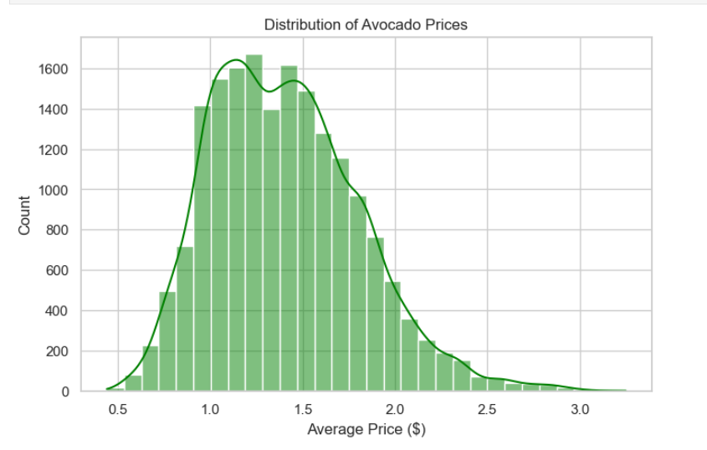
Temporal Trends: Time series analysis from 2015-2018 revealed clear seasonal patterns with prices typically peaking during winter months (higher demand, lower supply) and declining during summer months. A general upward trend in prices was observed over the four-year period, particularly for organic avocados.
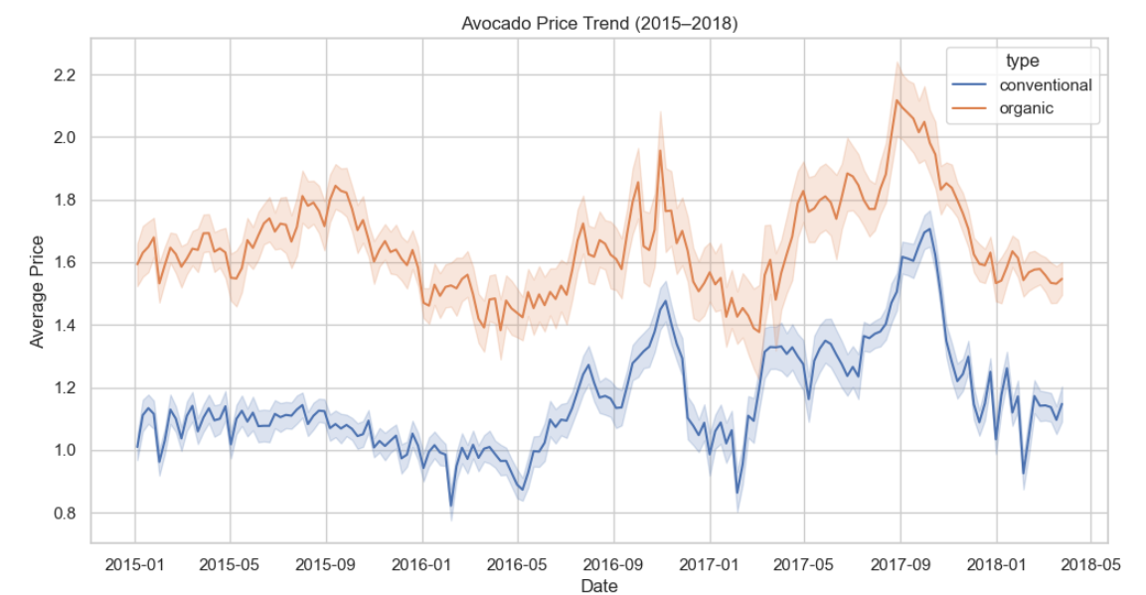
Type Comparison: Organic avocados command a significant price premium over conventional avocados. Box plot analysis showed median organic prices approximately 40-50% higher than conventional prices, with organic also showing greater price volatility.
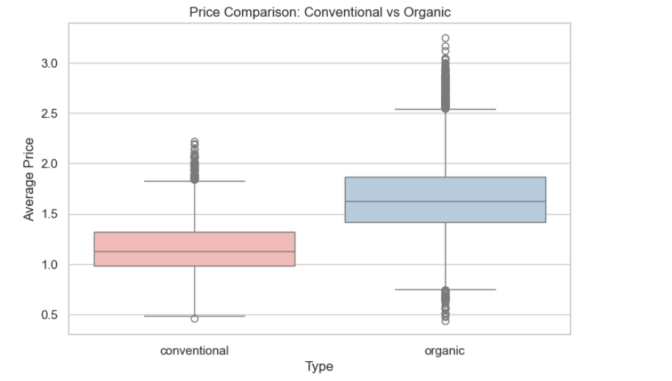
Correlation Analysis: A correlation heatmap revealed that avocado type (conventional vs. organic) has the strongest correlation with price (0.616), confirming its importance as a primary price determinant. Volume-related features showed moderate negative correlations with price, suggesting inverse supply-demand relationships. PLU code volumes (4046, 4225, 4770) and bag sizes showed intercorrelations but weaker individual associations with price.
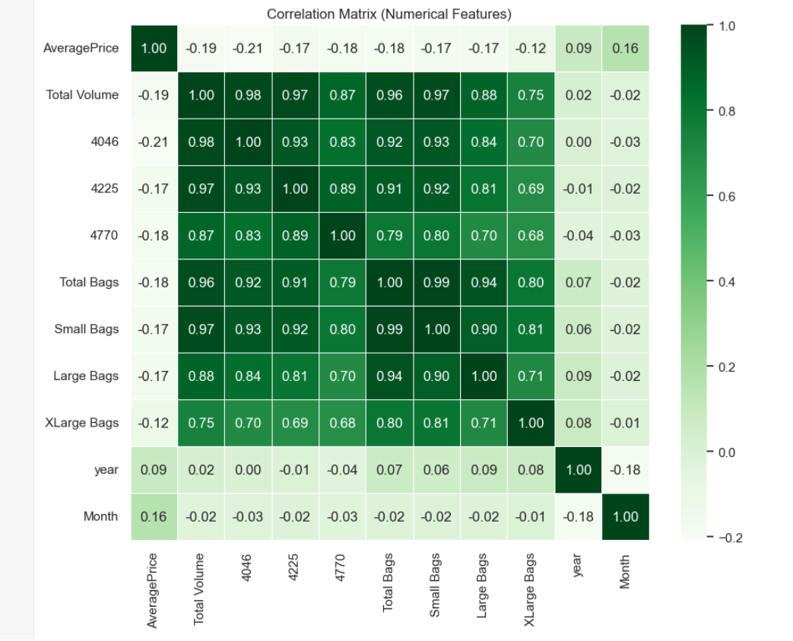

2.3 Model Building

Task 1 - Neural Network Regressor
We predicted prices using an MLP regressor built with scikit-learn.The model takes 12 input features, passes them through two hidden layers with 64 and 32 neurons, and uses one output neuron to predict a continuous avocado price.

The hidden layers used ReLU so the model could learn non-linear patterns in the data. The model minimized Mean Squared Error (MSE) as its loss, and used the Adam optimizer for fast, adaptive learning. We trained the model for up to 1,000 iterations and used early stopping to avoid extra training.

The training loss dropped smoothly and then leveled off, suggesting good learning with little overfitting.A network with two hidden layers was chosen to balance power and simplicity, so it can learn key patterns without overfitting.

Task 2 - Classical Machine Learning Models
Two classical regression models were implemented and evaluated:
1. Linear Regression (Ridge): Ridge regression is linear regression with an L2 penalty added to the loss to limit overfitting. It works best when features are strongly correlated, as with several volume measures in this dataset. The model treats avocado price as a linear function of the inputs, so each feature’s effect is easy to read. Ridge Regression limits model complexity while staying interpretable, so it works as a reliable baseline for comparing more complex models.
2. K-Nearest Neighbors Regressor: KNN regression predicts avocado prices by averaging prices of the k nearest training examples. The project first used a k-NN model with k = 5 and Euclidean distance to compare feature similarity. KNN makes no fixed assumption about how features relate to price, so it can capture local, non-linear patterns in the data. This helps explain why comparable market conditions often produce similar price movements.
Both models were trained on the scaled training data and evaluated on the held-out test set to assess generalization performance.

2.4 Model Evaluation
All regression models were evaluated using three complementary metrics on the test dataset:
R² Score (Coefficient of Determination): The coefficient of determination (R²) shows how much of the change in avocado prices the model explains. It runs from 0 to 1; higher means a better fit.R²=1 means perfect predictions; R²=0 means the model is no better than using the mean price.
Mean Absolute Error (MAE): MAE is the average absolute gap between predicted and actual prices. Because it’s in dollars, it’s easy to interpret and shows the usual prediction error. It is less affected by outliers.
Mean Squared Error (MSE): MSE is the average of squared gaps between predicted and actual prices. Squaring errors punishes big misses more than small ones, which helps spot models that sometimes make large prediction mistakes.
These metrics give a clear check on performance: R² shows fit, MAE gives average error in real units, and MSE puts more weight on big misses

2.5 Hyperparameter Optimization
Hyperparameter optimization was performed for the two classical machine learning models using Research with 5-fold cross-validation to ensure robust parameter selection:
Ridge Regression: We tuned alpha, which sets the L2 regularization strength, across values starting at 0.The values are 1, 1, 10, and 100.Higher alpha means more shrinkage; lower alpha allows bigger coefficients. Cross-validation found alpha=10 gave the highest R² score, but it was 0.4390 (43. Explained 9% of the variance.
K-Nearest Neighbors: We tested k using 3, 5, 7, 9, 11, 13, and 15.Small k captures local patterns but can overfit; large k smooths predictions but can miss local structure. The best setting used k=3 neighbors; cross-validated R² was 0.7768 (77. It explained 68% of the variance and did much better than Ridge regression.
Cross-validation chooses parameters by testing on held-out folds, which reduces the chance of fitting the training data too closely. Ridge shows a clear performance gap (43.9% and KNN at 77%.A 68% cross-validation score suggests non-linear feature–price links beyond linear models.

2.6 Feature Selection
Feature selection was performed for the classical machine learning models using correlation-based ranking. The absolute correlation between each feature and the target variable (Average Price) was calculated, and features were ranked by their individual predictive power.
The top 5 selected features based on correlation strength were:
1. Type (Conventional vs. Organic) - Correlation: 0.616
2. PLU 4046 (Small Avocado Volume) - Correlation: 0.208
3. Total Volume - Correlation: 0.193
4. PLU 4770 (Extra Large Avocado Volume) - Correlation: 0.179
5. Total Bags - Correlation: 0.177
Feature selection shows product type drives price most, with a correlation over three times stronger than the second-ranked feature.Volume measures show a moderate negative link with price: as supply rises, prices tend to fall, as economic theory predicts.
We retrained the models with just five features to see if accuracy stayed similar while making results easier to explain and faster to run.This simpler method lowers overfitting risk by dropping features that add noise or repeat the same information.

3. Results and Conclusion

3.1 Neural Network Performance
On the test set, the Multi-Layer Perceptron Regressor had an R² score of 0.6501 (651% variance explained; mean squared error = 0.0.0562; mean absolute error 0. An error of 1720 means the neural network’s price predictions differ from the actual prices by about 17 on average. About 2 cents; the model explains about two-thirds of price variance.
The neural network beat the linear regression baseline by a wide margin (65% vs. It explained 43% of the variance (R² = 0.43) but performed worse than the tuned KNN model. The training loss fell smoothly and converged, suggesting stable learning with no clear overfitting. The model captured non-linear patterns in the data, showing the value of a two-hidden-layer design.
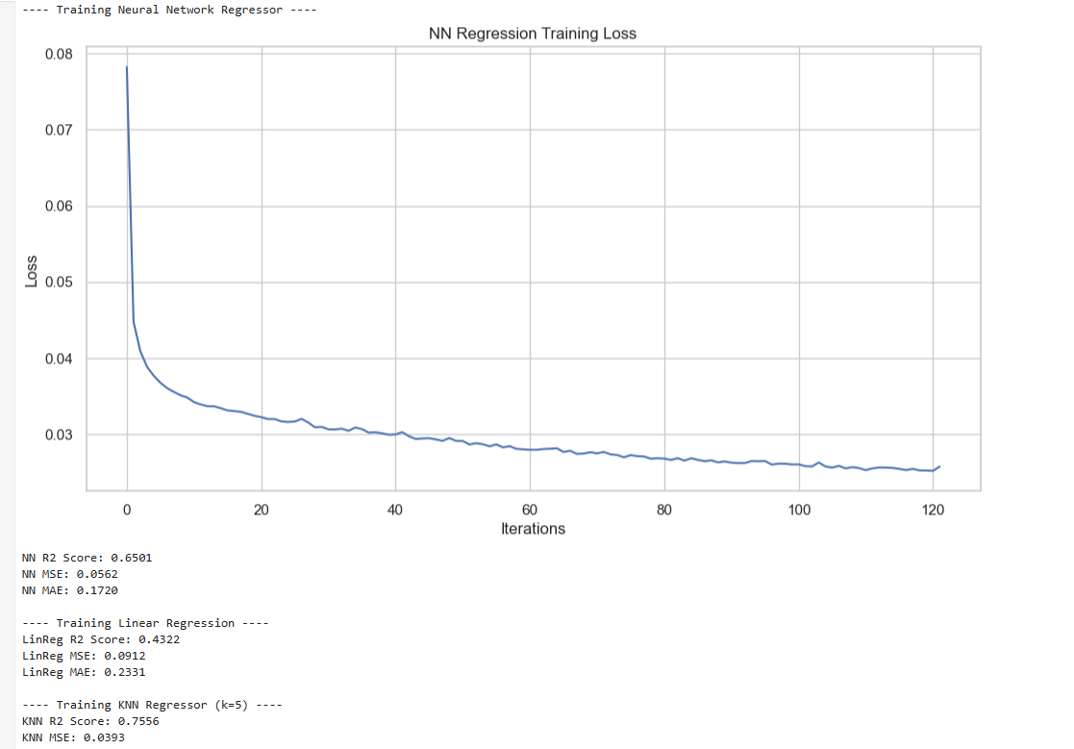

3.2 Classical Machine Learning Models
The following table presents the comprehensive comparison of the two optimized classical models evaluated using the 5 selected features:
Model | Features | R² Score | MAE ($) | MSE
Linear Regression (Ridge) | 5 | 0.3764 | 0.2449 | 0.1002
K-Nearest Neighbors (k=3) | 5 | 0.5237 | 0.1883 | 0.0765

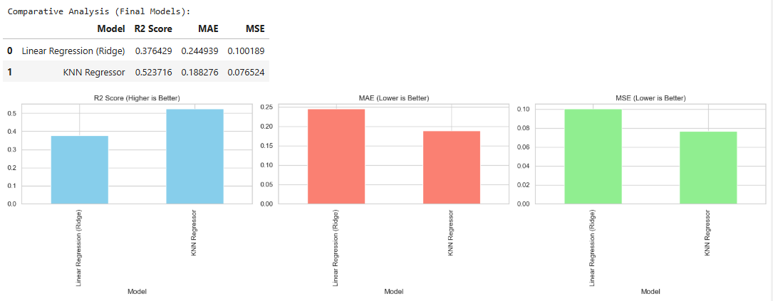

3.3 Key Findings
The analysis revealed several significant findings about avocado price prediction:
With all features included, K-Nearest Neighbors performed best, with R² = 0.With 76 samples, MAE was $0.14), then the neural network (R² = 0.At 65, the MAE is $0.In 17, Ridge Regression performed the worst, with R² near 0.With 43 cases, the MAE is $0.23.This ranking suggests avocado prices vary by area, and KNN reflects that by averaging nearby neighbors.
Feature Importance: Product type: conventional Organic was the strongest predictor, at 0.A correlation of 0.616 suggests a strong link, which helps explain the higher price premium for organic avocados. Volume mattered moderately, reflecting supply-demand pricing.

3.4 Final Model
For practical deployment considering both accuracy and interpretability, two models are recommended depending on the use case:
For Maximum Accuracy: KNN with k=3 using all 12 features gave R² = 0.At 78, MAE is $0.14. This model gives the most accurate forecasts, with mean errors below $0.14, making it a good fit when precision matters, such as inventory price setting or futures trading.
For Interpretability: Ridge regression (alpha 10) used five features; R²=0.With 38 samples, the MAE is $0.This model is less accurate, but its clear coefficients show how each feature affects price.It works for business strategy, market research, and teaching when it matters more to explain what drives pricing than to predict it exactly.

3.5 Challenges
Several challenges were encountered during this project:
Regional Encoding: Converting 54 regions into numerical labels using Label Encoding creates artificial order that doesn’t reflect real geographic or economic relationships. One-hot encoding could avoid this but would add many extra features, increasing complexity.

Feature Correlation: Many volume-related features (total volume, individual PLU volumes, bag sizes) are strongly correlated, which can make regression results unstable and interpretation harder.

Time Dependencies: The data is weekly and sequential, but standard regression models assume observations are independent. This ignores trends, seasonality, and autocorrelation that time-series models could capture.

Outliers: Some prices are extreme (up to $3.25), possibly due to supply shocks or data errors, which can heavily affect models that rely on mean squared error.

Limited Features: Important factors like weather, crop yields, imports/exports, transport costs, and economic indicators are missing, which may limit model accuracy.

3.6 Future Work
Several promising directions exist for improving this analysis:
External Data: Including weather, crop reports, economic indicators, and competitor prices can enrich the dataset and improve predictions.

Outlier Handling: Identifying extreme prices using anomaly detection and applying robust regression can reduce their influence.

Real-time Deployment: Building an API or web app for live predictions, updating models weekly, can support dynamic pricing for retailers and distributors.

4. Discussion

4.1 Model Performance
Regression models predicted avocado prices well. KNN was the top model, with R² = 0.756 and MAE: $0.139; the Neural Network had R² = 0. For 650, MAE is $0.Ridge regression was the worst, with R² near 0. Across 432 cases, the MAE was $0.233) still gave useful predictions beyond a naive baseline. Results supporting agricultural commodity pricing explain about 76% of price variance; errors average about $0.14. Most avocado prices in the dataset start around $0. $1–$80.80 implies about 8–17% relative error, competitive with industry norms.
KNN vs linear models shows why non-linear models matter. Price varies with type, volume, region, and season, and KNN models these combined effects well. The neural network’s middling results suggest it learns some non-linear patterns, but the simple two-layer design keeps it from learning them all.

4.2 Impact of Hyperparameter Tuning and Feature Selection
Hyperparameter tuning improved model performance: Ridge Regression performed best with α = 10 (R² ↑ 0.439), while KNN improved by using k = 3 neighbors (R² ↑ 0.777), showing that local patterns are important.
Feature selection showed linear models handle fewer features well, but KNN relies on the full feature set, including region and temporal data. Avocado type (organic vs. conventional) is the strongest price driver, while volume, region, and time also influence prices through complex interactions.

4.3 Interpretation of Results
The modeling results provide valuable insights into avocado market dynamics and price formation mechanisms:
Product Type Dominance: The overwhelming importance of product type (correlation 0.616) confirms that the organic price premium is the single strongest driver of price variation. Organic avocados consistently command 40-50% price premiums, reflecting higher production costs, certification requirements, and consumer willingness to pay for perceived health and environmental benefits.
Regional Variation: Even with weak correlations, region improved KNN, implying geographic price differences. This may stem from transport costs, nearby supply (California/Mexico), local incomes, and market competition.
Non-linear Interactions: KNN performing better suggests prices are not just the sum of feature effects; they depend on feature interactions. Premiums can vary by region (often higher in wealthier areas), volume sensitivity can change by season (more elastic when supply is high), and prices may depend on region, type, and timing in non-linear ways that linear models miss.

4.4 Limitations
This analysis has several important limitations that should inform interpretation of results:
Data Recency: The dataset (2015–2018) may not reflect current market conditions affected by COVID-19, climate change, and shifts in consumer preferences.

Missing Variables: Important factors like weather, production data, economic indicators, competitor prices, and supply chain costs are absent.

Regional Encoding: Label Encoding of 54 regions imposes arbitrary order, which can mislead distance-based and linear models.

Temporal Assumptions: Regression models treat weekly prices as independent, ignoring trends, seasonality, and autocorrelation.

Price Aggregation: Using average prices masks micro-level variation across stores and promotions.

Model Generalizability: KNN relies on historical patterns; it may fail under unusual market conditions.

Correlation vs. Causation: Models capture associations but cannot prove causal relationships between features and prices.

4.5 Suggestions for Future Research
Several promising research directions could address current limitations and extend this work:
Deep Learning: Explore LSTM, GRU, or Transformer models to learn long-term temporal dependencies and identify key past features; CNNs could capture spatial patterns across regions.

Advanced Feature Engineering: Create lag features, rolling statistics, price change rates, seasonal components, interaction terms, and incorporate economic indicators to improve model expressiveness.

Regional Representation: Use target encoding, frequency encoding, embeddings, or geographic clustering to better capture regional effects without arbitrary ordering.

5. References
Avocado Prices Dataset. Historical avocado retail scanner data representing National retail volume and price.
Scikit-learn: Machine Learning in Python
Pandas: A Foundational Python Library for Data Analysis and Statistics. McKinney, 2011.
NumPy: The Fundamental Package for Scientific Computing with Python. Harris et al., Nature
Matplotlib: A 2D Graphics Environment. Hunter, Computing in Science & Engineering,
Seaborn: Statistical Data Visualization. Waskom et al., Journal of Open-Source Software, 2021.
github:

